COLLECTIVE EXHIBITION: CUBA - USA / FRANCE 2016

HUMAN BEINGS: WHAT UNIFIES US?

PROJECT: TRAVELLING EXHIBITION
TO THE UNITED STATES AND EUROPE

ORGANIZER: Violaine Philippe-Walker
Violaine67@gmail.com
PR Agent for Artists and admirer of the Artistic Cuban “new wave”.
COLLABORATOR: Thierry Roels
French Photographer

For several years, Violaine Philippe-Walker has established links between "La Isla Bonita", the US and Europe, promoting Cuban artistic beauty. She dedicates her activity to painters, sculptors and photographers who have some fame on the Caribbean/South American market but for the most part have not yet had the chance to be exposed in Europe or the US for lack of resources or contacts.
The first Exhibitions took place in Havana and Trinidad during the Winter/Spring of 2016 and is looking for hosts in the US and Europe for 2017 as well as other young international artists who wish to join the group:
The original idea: “Human Beings: What unifies us?” was born after the official reopening of negotiations between the US and Cuba.
There is a strong force leading Cuban artists to share their creativity with the rest of the world. Our Artists, who are 27 to 64 years old, together represent a very eclectic panel of Cuban, American and French Art which is intended as a unifying element of Brotherhood in a world craving Peace and Beauty.

Human Beings: What unifies us?

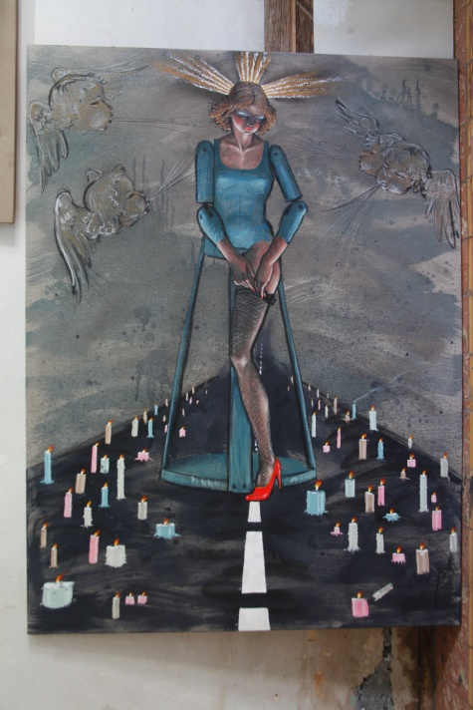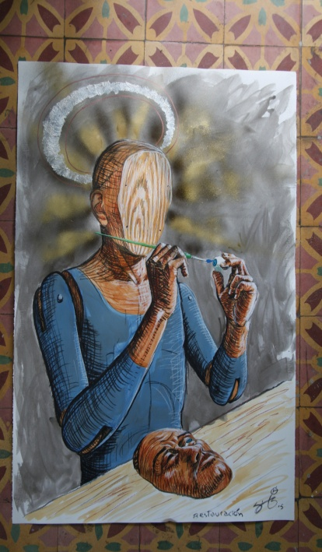
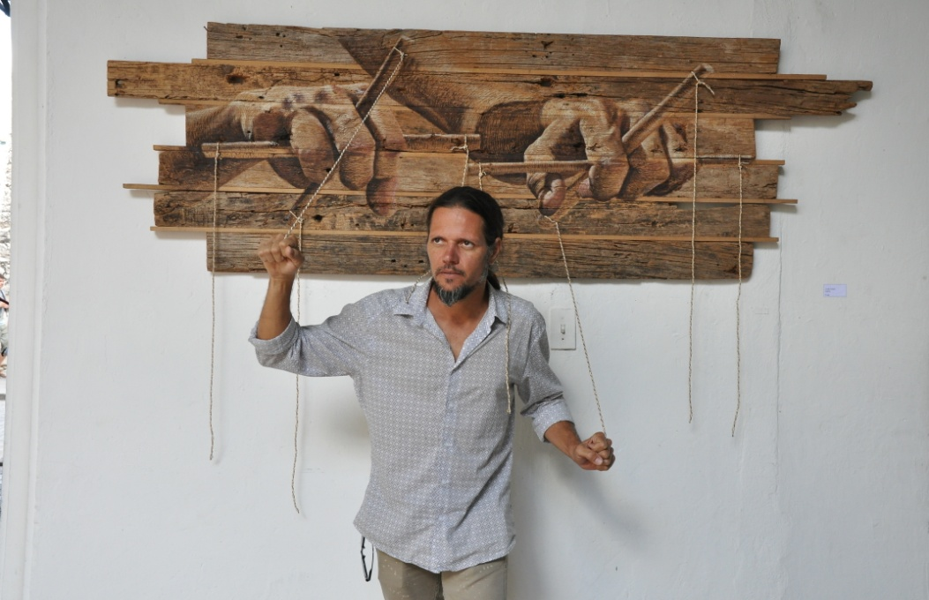
JORGE CESAR SAENZ
He was born in Trinidad, Cuba, in 1972. He attended the National School of Art "ENA" in Havana, graduated in 1990: painter, sculptor and engraver. He reaches for traditional or contemporary plastic resources to offer a renewed and timeless vision of ourselves.

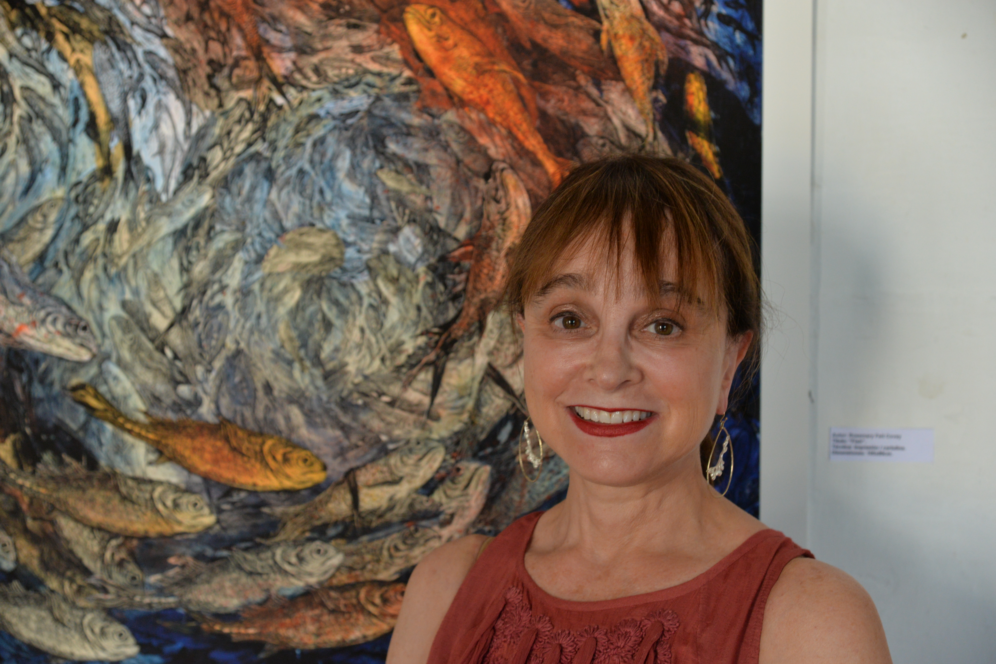

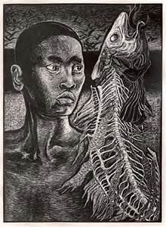
ROSEMARY FEIT COVEY
Born in 1954, Rosemary Feit Covey is an American printmaker, whose work focuses on wood engraving. She was born in Johannesburg, South Africa and studied at Cornell University and the Maryland Institute College of Art. She currently resides in Alexandria, Virginia, and has a studio at the Torpedo Factory Art Center.

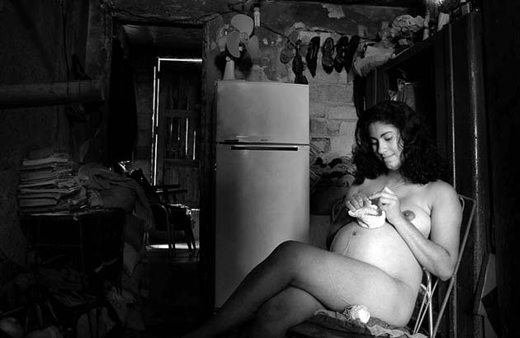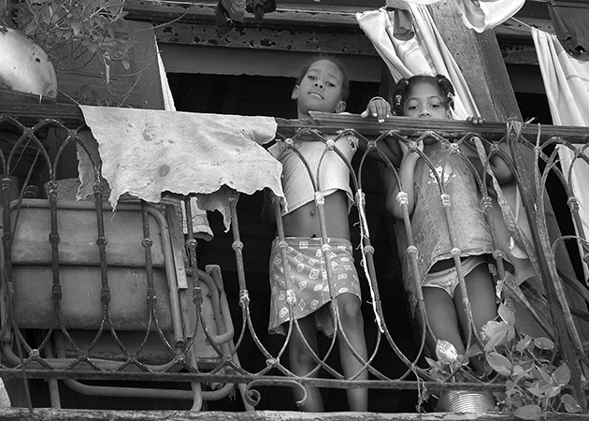

LAZARO LUIS GARCIA DEL CAMPO
Cuban Photographer born in 1966 who thrives to show the “Human heart to heart connection” through his work. He mixes deep realism and classical beauty and won several National Prizes for his black and white series.
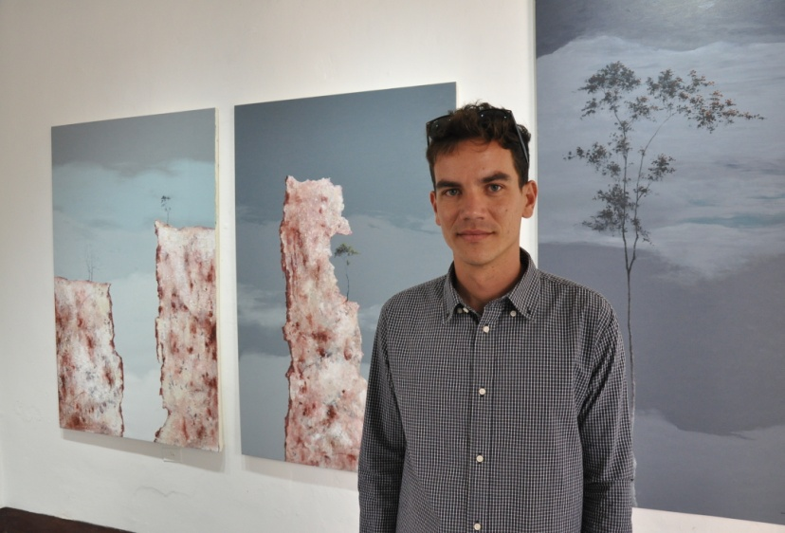

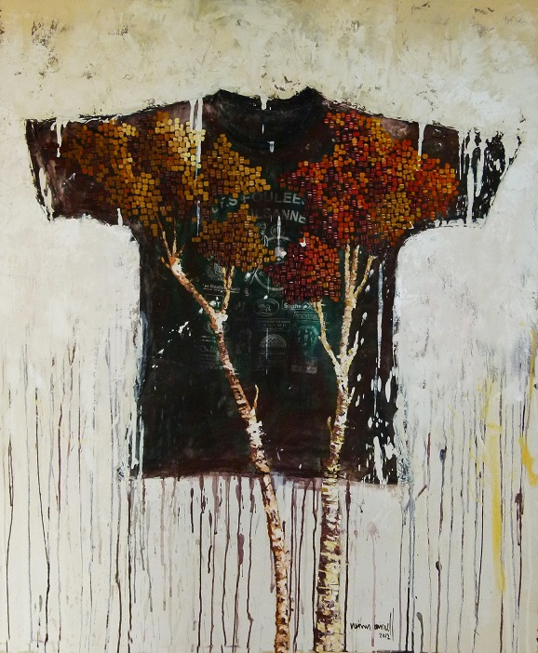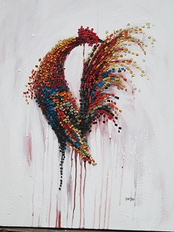

REYNIER BORRELL
Young Cuban Artist who was born in 1988. His work tends to represent the challenges that the Cuban society faces: keeping its traditions while moving forward. He uses “The Tree” as a symbol with a very particular technique: oil on canvas and collage.

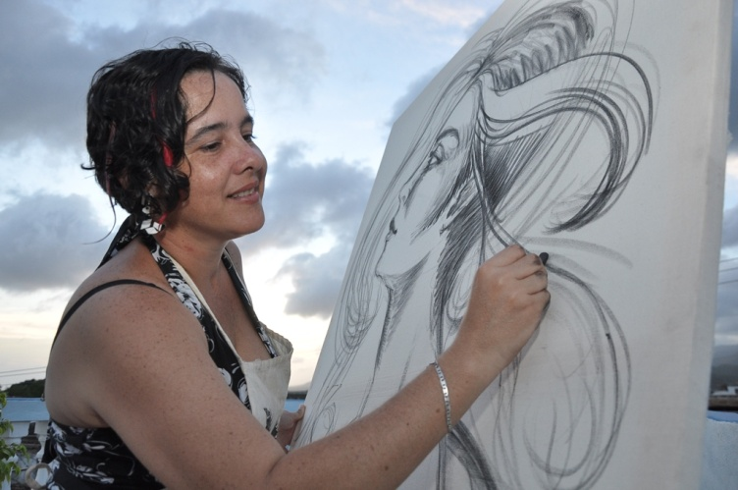

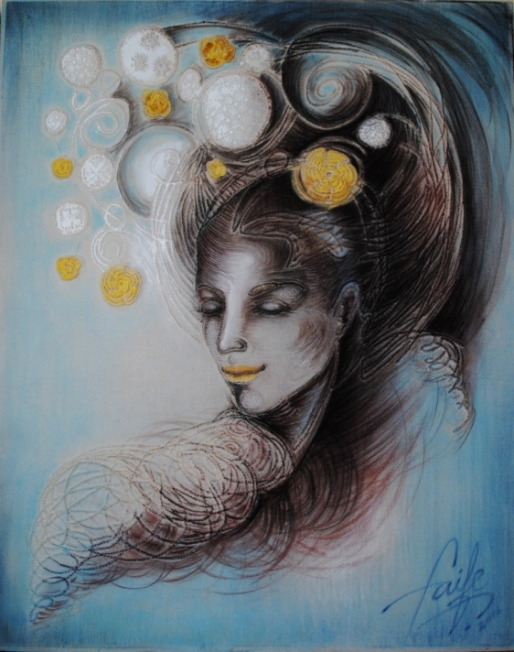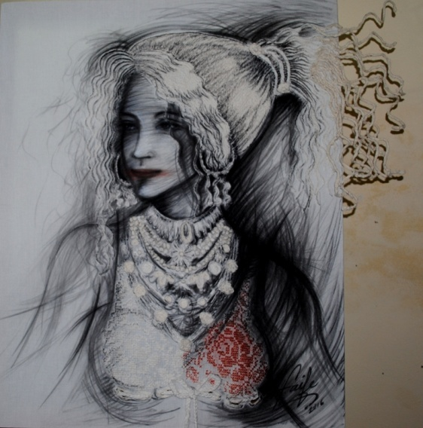

YUDIT VIDAL FAIFE
Yudit Vidal was born in 1979 in Santa Clara, Cuba. She currently resides in Trinidad. Her technique is inspired by the woman’s energy in general, especially an old Cuban tradition of women weaving cotton. She incorporates lace to her painting and gives a 3D dimension to her Work of Art. She will be representing Cuba with her work as an Ambassador of Peace to the UN in December 2016.
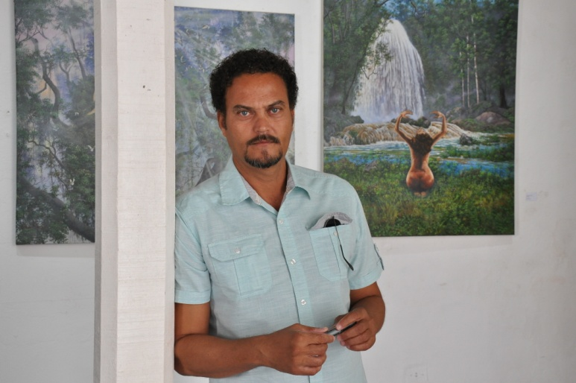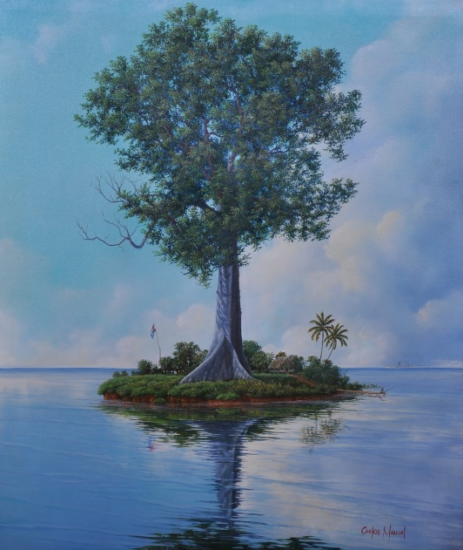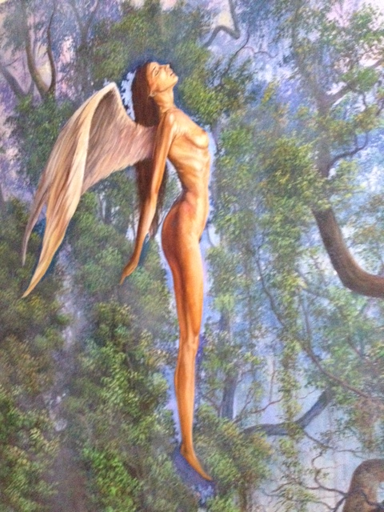

CARLOS MANUEL CASTILLO
Born in 1968 in La Palma, Pinar del Rio, tobacco land in Cuba. Independent painter and landscape Artist by excellence; his work technique is oil on canvas. He’s able to reflect the wonders of Nature with emotion and takes a path to the controversial reality of the Cuban society.

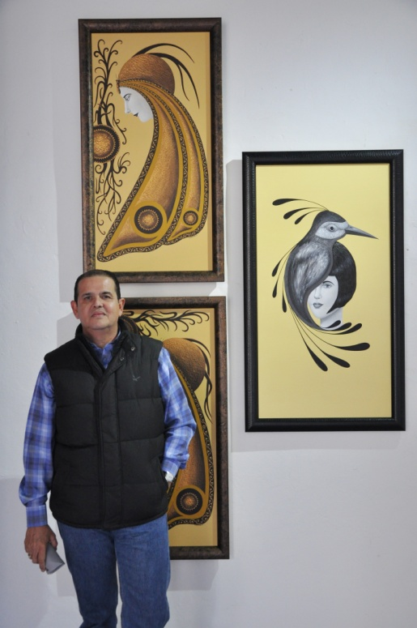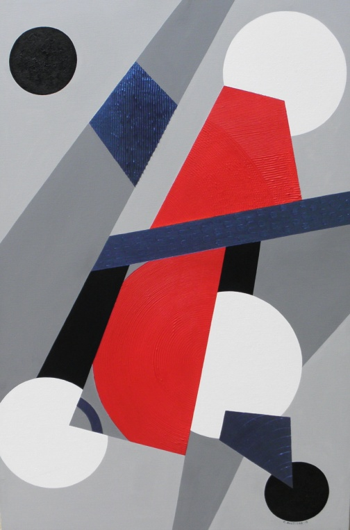

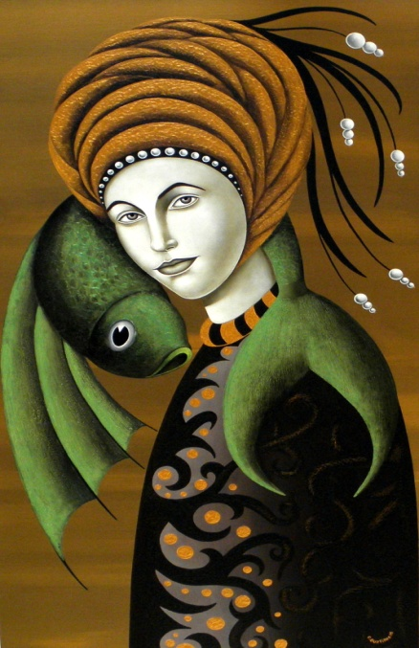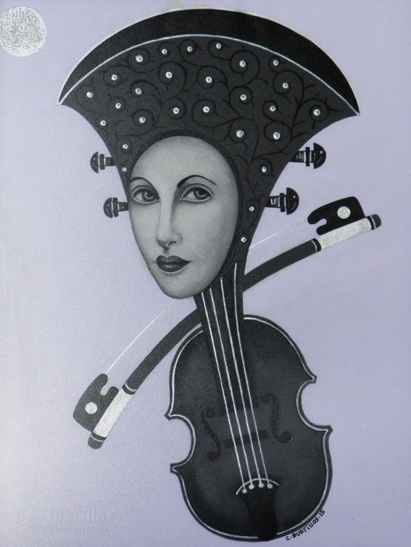
CARLOS MANUEL BUSTILLOS
He was born in 1961 and what inspires him is:
Life, nature, human beings and especially the female figure, which is accompanied by butterflies, fish, birds, fans, shells, all integrated to decorate and highlight the feminine image.
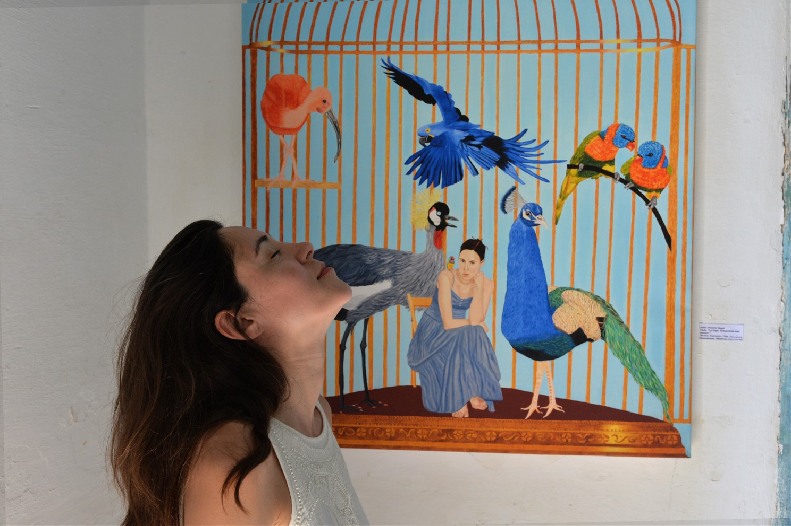
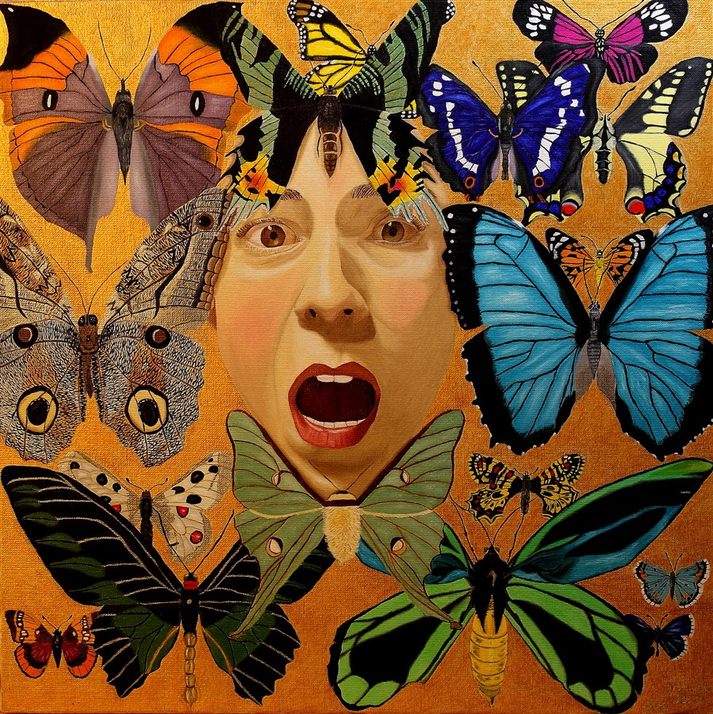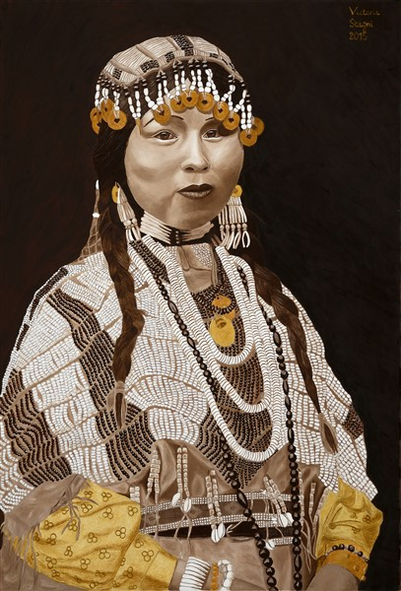

VICTORIA STAGNI
Born in 1973, Victoria Stagni did her apprenticeship in the oil painting at Pierre Lafage (graduate of the Beaux-arts de Paris and Bordeaux). Her figurative painting, naive style, oscillates between realism and fantasy.

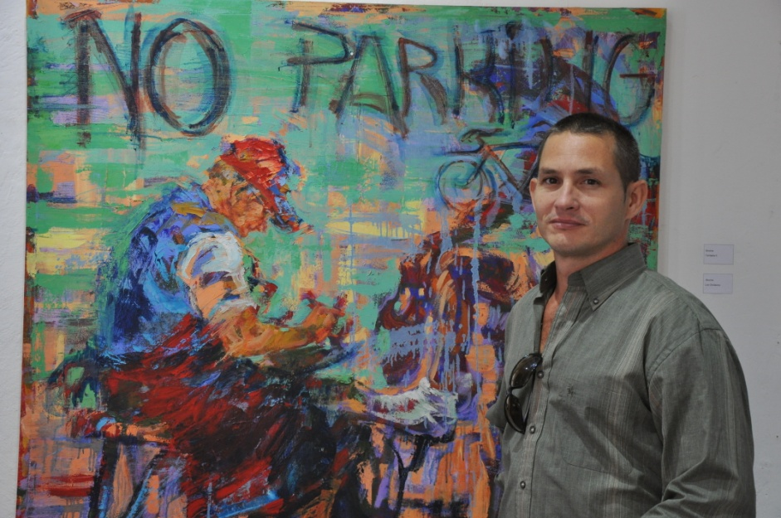
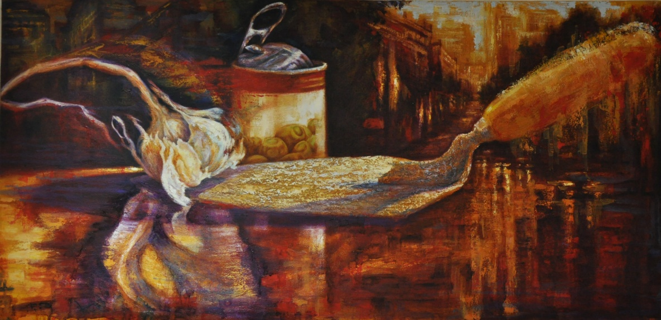

ARIEL BROCHE
Cuban Artist born in 1975 in Trinidad. Independent Artist who started his career as a baker and fell in love with oil on canvas. His inspiration comes from the men’s hard labor or nature that surrounds him.

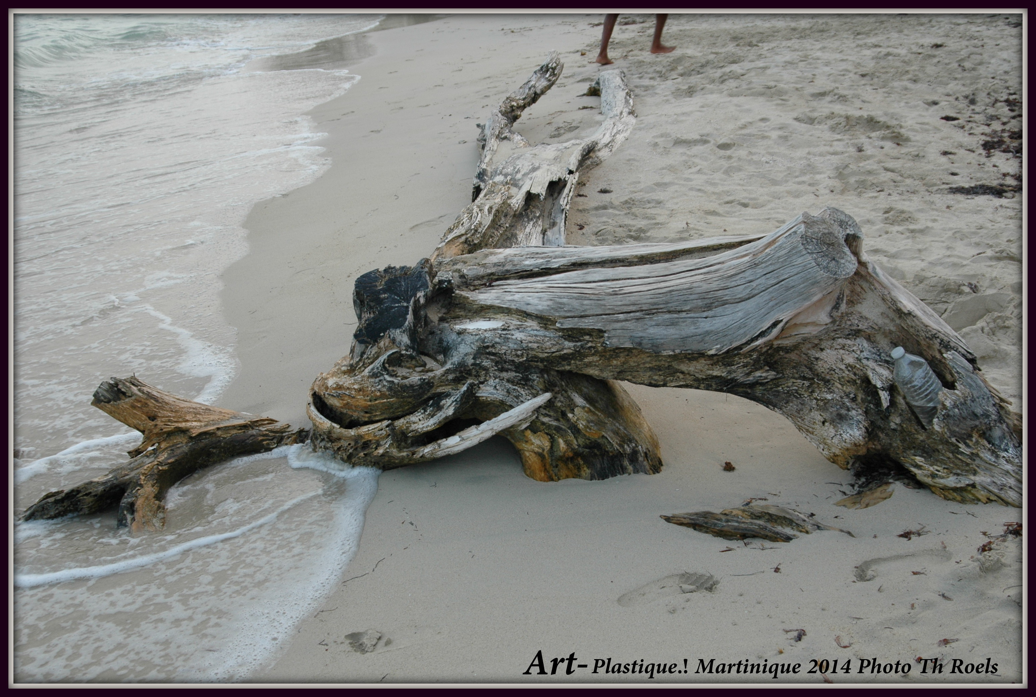

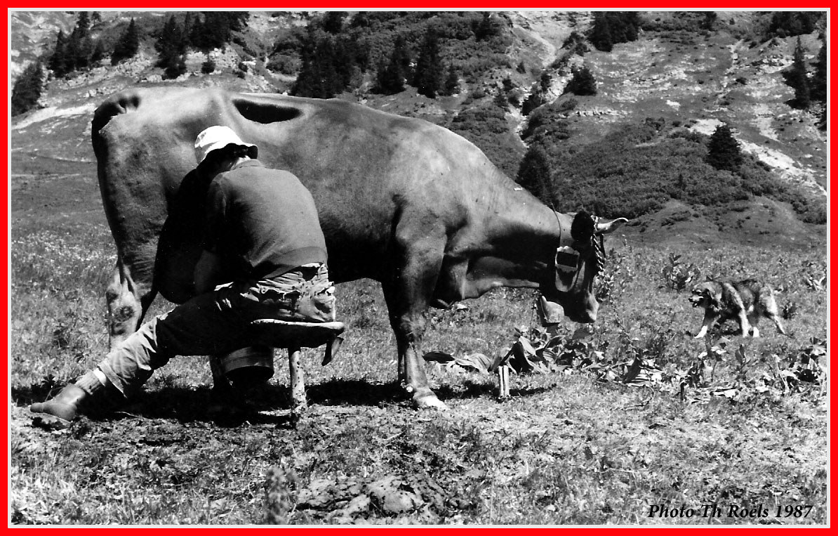
THIERRY ROELS
French Photographer born in 1952 who thrives to show the impact of Humans on Nature and the preciousness of our ancestral traditions. He calls his personal project “Plastique Art” to raise awareness about contamination on Earth.

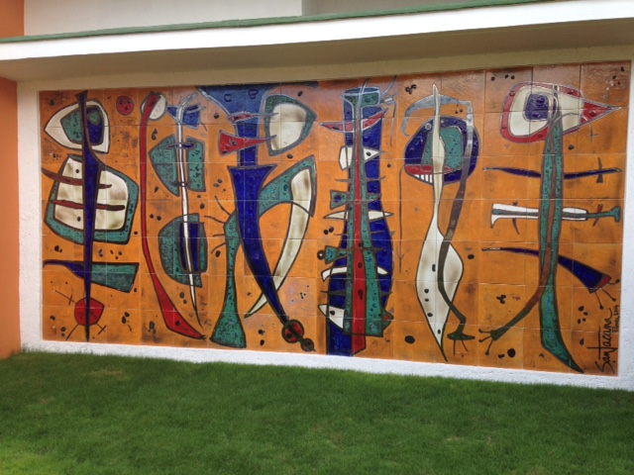

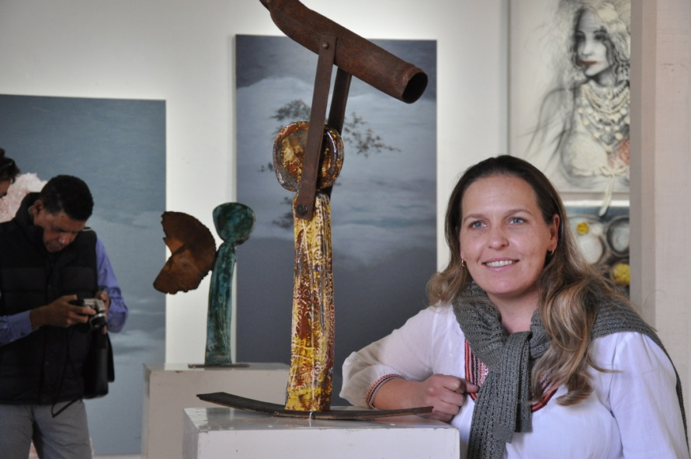

BEATRIZ SANTACANA
Cuban woman sculptor self-educated in the world of Art who participated in the last Havana Biennial 2015. Her idea is to show the modern world in motion while building “human frames” in ceramic mixed with recycled material such as rusted metal or wood.

